Assessment: Assignment 03

Student Name: Adam Di Cioccio

Lab Professor Name: Mohammad Patoary

Lab Section Number: 321

Due Date: November 25, 2020

# Understand the problem

The main objective of this assignment is to make a math incorporated program that takes only a number between -10000 and 10000 using an if statement. The if statement would perform calculations based on if the number entered is between -10000 to 10000 else if restart the program. The program will then ask the user for another input to perform desired calculations to the 2 operands.

# Develop and Describe an Algorithm

***UML***

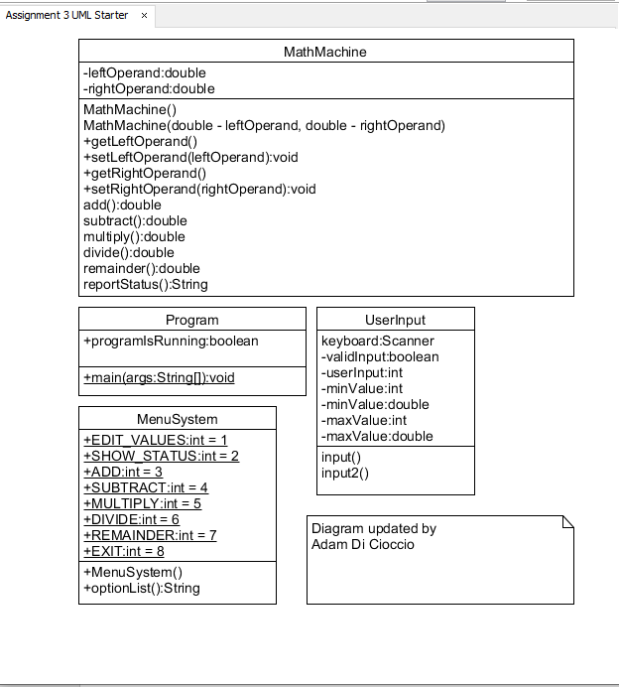

***Pseudocode***

Program.java(main)

New class MathMachine as math

New class MenuSystem as menu

New class UserInput as user

Boolean programIsRunning set to true;

While loop (programIsRunning)

Call MenuSystem and print menu

Ask user for input

Call UserInput and set into int

If statement (input = 1)

Ask user for left operand

Call UserInput and set into double

Call method setLeftOperand and set left operand

Ask user for right operand

Call UserInput and set into double

Call method setRightOperand and set right operand

Else if (input = 2)

Call getter methods for operands from MathMachine

Print out left and right operand

Else if (input = 3)

Call add method from mathmachine and perform calculations specified

Else if (input = 4)

Call subtract method from mathmachine and perform calculations specified

Else if (input = 5)

Call multiply method from mathmachine and perform calculations specified

Else if (input = 6)

Call division method from mathmachine and perform calculations specified

Else if (input = 7)

Call remainder method from mathmachine and perform calculations specified

Else if (input = 8)

Print exiting

Set programIsRunning to false ending loop

***Flowchart***

Start

Create math, menu, user with classes MathMachine, MenuSystem, UserInput

+ Boolean programIsRunning

While loop (programIsRunning)

Prompt user with options from MenuSystem class

Prompt user for input (1-8)

Collect input and store in variable

If statement (Options 1-8)

Input = 1

Input = 4

Input = 3

Input = 2

Get user input for left and right operand

Call userInput command to verify numbers

Calculate diffrence

Calculate sum

Display operands

Input = 5

Input = 8

Input = 6

Input = 7

Calculate remainder

Calculate dividend

Calculate product

End if statement

Stop

# Test Algorithm with Simple Inputs

|  |  |  |  |  |
| --- | --- | --- | --- | --- |
| Internal Input | User input | Expected output | Actual output | Desciption |
| minValue = 1  maxValue = 8 | 0 | Invalid input. Please try again. | Invalid input. Please try again. | Not in range (1 – 8) |
| minValue = 1  maxValue = 8 | 1 | Please enter an option from -10000 to 10000 | Please enter an option from -10000 to 10000 | Performs logic and asks user for input |
| minValue = 1  maxValue = 8 | 2 | Left operand: 0.0  Right operand: 0.0 | Left operand: 0.0  Right operand: 0.0 | Displays operands |
| minValue = 1  maxValue = 8 | 3 | Sum: 0.0 | Sum: 0.0 | Performs calculations |
| minValue = 1  maxValue = 8 | 4 | Difference: 0.0 | Difference: 0.0 | Performs calculations |
| minValue = 1  maxValue = 8 | 9 | Invalid input. Please try again. | Invalid input. Please try again. | Not in range (1 – 8) |
| minValue = 1  maxValue = 8 | banana | Invalid input. Please try again. | Invalid input. Please try again. | Matches |

# Translate the Algorithm into Java

Java code in submission.

# 5a) Compile and Run Your Program

# 

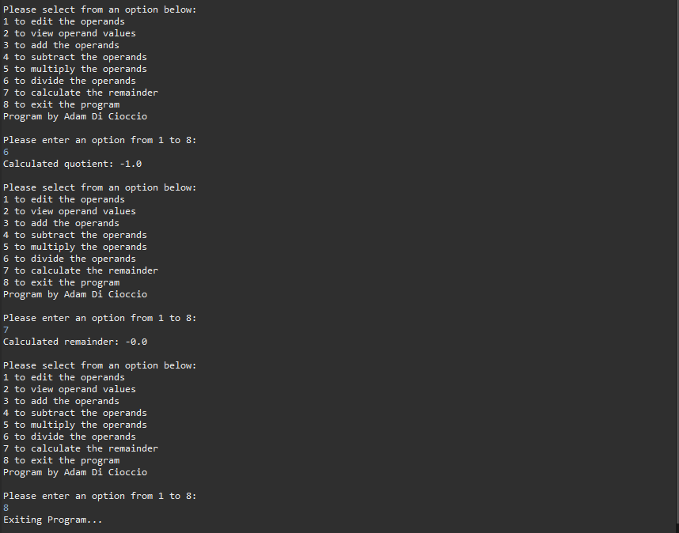

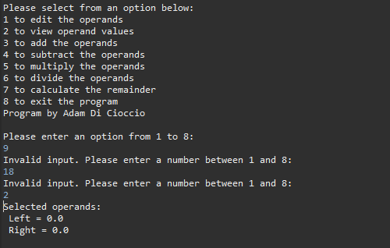

# 5b) Test Your Program

|  |  |  |  |  |
| --- | --- | --- | --- | --- |
| Internal Input | User input | Expected output | Actual output | Desciption |
| minValue = 10000.0  maxValue = -10000.0 | 0 | Return 0 | Return 0 | Matches |
| minValue = 10000.0  maxValue = -10000.0 | 10000 | Return 10000 | Return 10000 | Matches |
| minValue = 10000.0  maxValue = -10000.0 | -10000 | Return -10000 | Return -10000 | Matches |
| minValue = 10000.0  maxValue = -10000.0 | 9999999 | Invalid input. | Invalid input. | Matches |
| minValue = 10000.0  maxValue = -10000.0 | -932736 | Invalid input. | Invalid input. | Matches |
| minValue = 10000.0  maxValue = -10000.0 | 24.5 | Return 24.5 | Return 24.5 | Matches |
| minValue = 10000.0  maxValue = -10000.0 | banana | Invalid input. Please try again. | Return 0.0 | Returns nothing if entered wrong |

# 6) References